|  |  |
| --- | --- |
|  |  |

**Functional Specification Document**

Distribution Communication System

Version:

0.5

Department Owner:

<<Department Name>>

Updated:

16 April 2018

Deasy Agustria

**Approval**

By signing this section, the individuals listed below acknowledge that they have reviewed and approved the scope of the effort described in this Functional Specification Document (FSD) for Distribution Communication System. The signatures below represent the approval for execution of this FSD.

|  |  |  |  |
| --- | --- | --- | --- |
| **Prepared by** | | | |
| **Name** | **Designation/Role** | **Date** | **Signature** |
| Deasy Agustria | Business Analyst | 16 April 2018 |  |
| **Reviewed by** | | | |
| **Name** | **Designation/Role** | **Date** | **Signature** |
|  | Business Analyst SPV |  |  |
|  | Requestor |  |  |
| **Approved by** | | | |
| **Name** | **Designation/Role** | **Date** | **Signature** |
|  | Business Analyst Head |  |  |
|  | Requestor Manager |  |  |

*\*please do not remove, but add as necessary*

**Revision History**

*Please replace all revision history in table below once you use this template for your project purposes*

|  |  |  |  |
| --- | --- | --- | --- |
| Version No. | Date | Created by | Revision Description/ Reason for Revision |
| 0.1 | 23 February 2018 | Deasy Agustria | Initial Version |
| 0.2 | 5 March 2018 | Deasy Agustria | 1. Add database requirement (DFD), tbl_audit_trail 2. Change Email Body Parameter into Email Body Template 3. Report1: Filter Send Date change into Send Date Period 4. Report2: Filter Send Date change into Send Date Period |
| 0.3 | 29 March 2018 | Deasy Agustria | 1. Select agent via upload agent number 2. Max attachment file and format type parameterized in application properties 3. Housekeeping data in table receiver |
| 0.4 | 10 April 2018 | Deasy Agustria | 1. ERD 2. Database column in DCS 3. Data Access Requirements 4. Batch Process Description 5. Batch Process trigger |
| 0.5 | 16 April 2018 | Deasy Agustria | 1. Add flowchart |

**Distribution List**

This document shall be made available as soft copies to the following users below:

|  |  |  |  |
| --- | --- | --- | --- |
| **No.** | **Name** | **Designation/Role** | **Department** |
| 1. |  |  |  |
| 2. |  |  |  |
| 3. |  |  |  |

**TABLE OF CONTENT**

1 Introduction 1

1.1 Purpose 1

1.2 Objectives 1

1.3 Scope 1

1.4 Out of Scope 1

1.5 Assumptions, Dependencies, Constraints 1

2 User Scenarios 3

2.1 <User Scenario> 3

3 Functional Requirements 4

3.1 System Requirements 4

3.1.1 System Functionality Requirements 4

3.1.2 System Interface Requirements 19

3.2 Reporting Requirements 20

3.3 Data/DataBase Requirements 22

3.3.1 DataBase Requirements (DFD) 22

3.3.2 Data Access Requirements 28

3.3.3 Data Import/Export Requirements 28

3.3.4 Data Migration/Conversion Requirements 29

3.3.5 Data Backup, Restore, and Archiving Requirements 29

3.4 Batch Processes 29

3.4.1 Batch Process 29

3.4.1.1 Send Email Scheduler 29

3.4.1.2 Send SMS Scheduler 29

3.4.1.3 Send PRUforce Scheduler 29

3.4.2 Batch Description 30

3.4.2.1 Send Email Scheduler 30

3.4.2.2 Send SMS Scheduler 30

3.4.2.3 Send PRUforce Scheduler 30

3.4.3 Batch Process Description - Main Flow 30

3.4.3.1 Send Email Scheduler 30

3.4.3.2 Send SMS Scheduler 30

3.4.3.3 Send PRUforce Scheduler 31

3.4.4 Batch Process Description - Alternate Flow 31

3.4.5 Batch Process Dependencies 31

3.4.6 Batch Process Data Reference 32

3.4.7 Security 32

3.5 Non-Functional Requirements 32

3.6 Security Requirements 33

3.6.1 User Role/Authorization Control Requirements 33

3.6.2 User Administration Requirements 34

3.6.3 System Administration Requirements 34

3.6.4 Network Security Requirements 34

3.6.5 Physical Security Requirements 34

3.6.6 User ID Requirements 34

4 Glossary 35

5 Reference Documents 36

6 Attachments/Appendix 37

6.1 Site Map 37

6.2 Use Case Diagram 37

6.3 Page Specification 37

6.4 Report Design 37

6.5 User Interface and User Experience Design 37

# Introduction

## Purpose

The purpose of this **Functional Specification Document (FSD)** is to define the functional requirements for **Distribution Communication System.** The requirements specified in this FSD document define the system from a functional perspective. It includes the system, data, performance, configuration, security, operational, and maintenance capabilities that the systemmust provide in order to meet business needs.

Role: Business Analyst

## Objectives

The main objectives of Distribution Communication System are:

1. Can distribute information based on need
2. Can distribute information based on media/communication type
3. Can distribute information based on selected target

## Scope

Distribution Communication System is required to accommodate the following needs:

1. Input Message to be shared to Email, SMS, and News & Update PRUforce.
2. Send message to Email, SMS, and PRUforce.
3. Report 1 and Report 2
4. Parameter
5. Audit Trail

## Out of Scope

1. Sending message using chat apps (Whatsapp/Telegram)

## Assumptions, Dependencies, Constraints

<This section should list all applicable assumptions, dependencies or constraints. Associated risks and mitigation strategies should be mentioned.

In cases of larger projects, risks and mitigation can also be tracked separately by project managers and may not necessarily need to be articulated in this Document>

|  |  |  |  |  |
| --- | --- | --- | --- | --- |
| **#** | **Type** | **Description** | **Associated Risks** | **Mitigation** |
| 1 | Assumption | The info is distributed to the agents correctly. | * Agents do not get the proper info. * The info is shared to the person who is no longer our agent. | Information update campaign will be held through M3 & Agency meeting. |
| 2 | Assumption | The info is distributed to all agents. | There could be any agents who do not get the info. | * Add setting on how many queue on every sending to avoid traffic. * Add BCC to internal staff for monitoring system. |
| 3 | Dependency | The system to distribute communication depends on agent’s phone number and e-mail address. | The agent’s phone number and e-mail address is not up to date so that they do not get the info. | Information Update campaign will be held through M3 & Agency meeting.  Put data information change manually in PRUforce. |
| 4 | Dependency | Phone credit is used to send the information through SMS. | Not enough phone credit to send the info. | Used post-paid sim card and paid regularly using PAO budget. |
| 5 | Constraint | The attachment file is sufficient. | The attachment file is exceeded the capacity. | Need to identify file size capacity and system state clearly anytime an e-mail will be sent. |
| 6 | Constraint | The characters are used for SMS is sufficient. | The characters are used for SMS is exceeded the limit. | The system need to state clearly how many characters left. |

# User Scenarios

<A user scenario describes a sequence of tasks performed by a single user (type or role) to complete a logical unit of work. In this section, identify the use cases which will perform the user scenarios identified with the Personas. NOTE: This section will be built up in two steps. When identifying the personas, add scenarios into this section for each. When the use case model is being constructed identify which use cases will perform each part of the scenario to identify the full workflow for a scenario. Remember, the scenario steps are high-level and should be aligned to one use case, do not go too granular or it will duplicate the use case>

## <User Scenario>

|  |  |  |
| --- | --- | --- |
| Scenario Step | Description | Use Case |
| <Step # n> | <Describe the scenario step performed> | <Use Case ID> |
|  |  |  |

# Functional Requirements

## System Requirements

### System Functionality Requirements

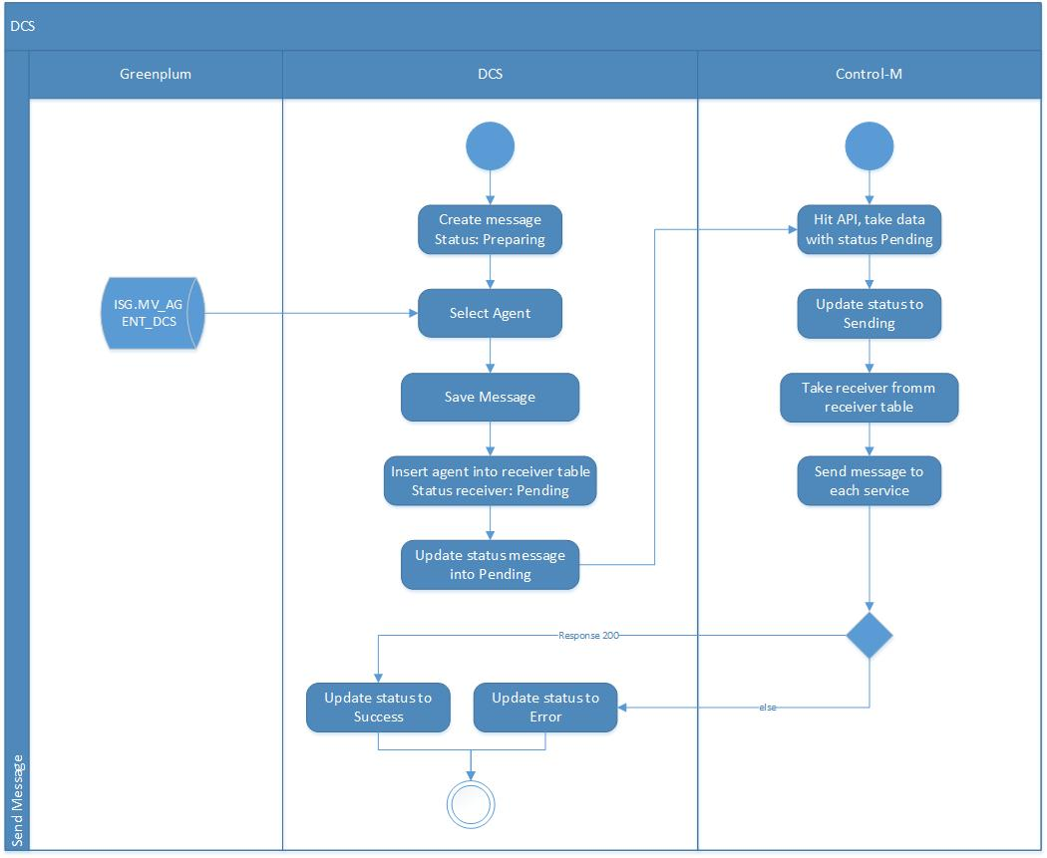

| **Requirement ID** | **Requirement Description** |
| --- | --- |
| 3.1.1.1 | **Compose Email:**   1. There is one email sender and it’s given by Prudential. 2. Text consists of 2000 characters and can be edited by colour, type, size, alignment, bold, and italic. 3. Maximum capacity for file attachment is parameterized in application properties. 4. Attachment file type is parameterized in application properties. 5. User may choose when the information will be sent. There are 2 types of time selection:  * Send Now: The user may send the info directly. * Send Later: The user may choose the specified date and hour to send the message. The user may only choose the date in the range of 10 days from the day that the message is ready to be spread.  1. If user select [Radio Button] Send Later, date picker for Send Later will be enable. User can choose date and time the message to send. 2. User can choose email template from email body template, if user edit the email it doesn’t change the email body template. 3. User may choose the agent’s profile, so the information is segmented for certain agent. 4. The user choose receiver (Agent) by find it manually and upload agent codes. 5. Agent Type: AG, MA, AA, AD, FC, MF, AS, NS, NA, GAO. 6. Receiver also has Office Code as filter. User can choose any Office Code, and the message will send to all the agent in that Office Code. |
|  | **Choose email body from template:**   1. If user click [Button] Search Email Template, system will show Email Body Template page. 2. User may search email template using Subject Email and Body Email as filter. 3. User can choose body email and then click [Button] Use, subject and body email in compose email page will automatically filled based on the chosen template. |
|  | **Choose receiver for Email:**   1. There are 2 types of selection email receiver such as find the receiver manually and upload agent code. 2. Find Agent Manually:   There are some agent filters such as Agent, Agent Type, and Office Code.   * Agent: user can search based on Agent Code or Agent Name. * Agent Type: AG, MA, AA, AD, FC, MF, AS, NS, NA, and GAO * Office Code: If user choose any Office Code, the message will sent to all agent in that office code. In office code there are button Select All, used to select all the office code list and button Deselect All, used to unselect the selected office code.      1. Upload Agent Code  * User can send email by using upload agent codes * System prepare template upload agent codes and user can download it * Upload agent code using plain text |
| 3.1.1.2 | **Compose SMS**   1. There is one SMS sender and it’s given by Prudential. 2. Text consists of 160 characters. 3. The message may be added with link to website or video for further info. 4. The user chooses receiver (Agent) and linked to the table Agent Profile. 5. User may choose the agent’s profile, so the information is segmented for certain agent. 6. User may choose when the information will be sent. There are 2 types of time selection:  * Send Now: The user may send the info directly * Send Later: The user may choose the specified date and hour to send the message. The user may only choose the date in the range of 10 days from the day that the message is ready to be spread  1. If user select [Radio Button] Send Later, date picker will be enable. User can choose date and time the message to send. |
|  | **Choose receiver for SMS:**   1. There are 2 types of selection email receiver such as find receiver manually and upload agent code. 2. Find Agent Manually   There are some agent filters such as Agent Type, Office Code, and Agent.   * Agent: user can search based on Agent Code or Agent Name. * Agent Type: AG, MA, AA, AD, FC, MF, AS, NS, NA, and GAO * Office Code: If user choose any Office Code, the message will sent to all agent in that office code. In office code there are button Select All, used to select all the office code list and button Deselect All, used to unselect the selected. |
| 3.1.1.3 | **Compose Push Notification to PRUforce**   1. The message will align with push notification feature which can inform to agents that there is news or update to them. 2. User may choose the agent’s profile, so the information is segmented for certain agent. 3. The user choose receiver (Agent) and linked to the table Agent Profile. 4. User may choose when the information will be sent. There are 2 types of time selection:  * Send Now: The user may send the info directly * Send Later: The user may choose the specified date and hour to send the message. The user may only choose the date in the range of 10 days from the day that the message is ready to be spread  1. If user select [Radio Button] Send Later, date picker will be enable. User can choose date and time the message to send. |
|  | **Choose receiver for PRUforce:**   1. There are 2 types of selection email receiver such as find the receiver manually and upload agent code. 2. Find Agent Manually   There are some agent filter such as Agent, Agent Type, and Office Code.   * Agent: user can search based on Agent Code or Agent Name. * Agent Type: AG, MA, AA, AD, FC, MF, AS, NS, NA, and GAO * Office Code: If user choose any Office Code, the message will sent to all agent in that office code.      1. Upload Agent Code  * User can send email by using upload agent codes * System prepare template upload agent codes and user can download it * Upload agent code using plain text |
| 3.1.1.4 | **Send message to Email**   1. Push notification to email will use Prudential SMTP. 2. System will get delivery report log.   Email with attachment:  - transactionId  - transactionTime : yyyy-MM-dd HH:mm:ss.SSS  - signatureString : current timestamp + 4 random number (hash using sha1)  - processCode : emailNew  - channelId : pruforce  - tos : receiver email address  - subject : subject email  - message : body email  - listAttachment : email attachment  {  “transactionId”:”1234”,  “transactionTime”:”2018-02-17 13:55:51.399”,  “signatureString”:”73c6c03fc0db05f8a24dff982aaa66ccadd77f1a”,  “processCode”:”emailNew”,  “channelId”:”pruforce”,  “tos”:”faisal.reza@prudential.co.id”,  “subject”:”test”,  “message”:”test”  } |
| 3.1.1.5 | **Send message to SMS**   1. Push notification to SMS will invoke Prudential existing SMS webservice (REST API) 2. Prudential already has SMS Gateway. 3. System will get delivery report log.   - transactionId  - transactionTime : yyyy-MM-dd HH:mm:ss.SSS  - signatureString : current timestamp + 4 random number (hash using sha1)  - processCode: smsmitracom  - channelId: pruforce  - phoneNo : receiver mobile phone  - message  {  “transactionId”:”1234”,  “transactionTime”:”2018-02-17 14:07:27.995”,  “signatureString”:”6e1ed5a28408a612694f610fb09f26be8103a991”,  “processCode”:”smsmitracom”,  “channelId”:”pruforce”,  “phoneNo”:”085779311279”,  “message”:”test message”  } |
| 3.1.1.6 | **Send message to PRUforce**   1. Push notification to PRUforce will invoke Prudential webservice (REST API)  * userid * eventid * token * subtituteParam * message * newsId * agentType   [  {  “userid”: “00001273”,  “eventid”: 26,  “token”: “”,  “subtituteParam” : {  “message”:””,  “newsId”:””,  “agentType”:[]  }  },    {  “userid”: “00841117”,  “eventid”: 26,  “token”: “”,  “subtituteParam” : {  “message”:””,  “newsId”:””,  “agentType”:[]  }  }  ] |
| • **Query to get news update**  SELECT ‘NewsUpdate’ AS obj_id, replace(array_to_string(array(SELECT row(‘’’’ ||a.id||’’’’,’’’’||b.id||’’’’,’’’’||b.agent_type||’’’’)  FROM security.m_agent_type a, newsupdate.t_news, newsupdate.m_news_type c  WHERE cast (array[a.id::text] as text []) && (regexp_split_to_array(regexp_replace(b.agent_type, ‘^’, ‘’, ‘’),’,’)) AND b.news_type_id = c.id  AND b.activated IS TRUE AND date(b.start_publish_date) = CURRENT_DATE), ‘,’), ‘’’’,’’) AS VALUE  • **Query to generate json**  SELECT a.agent_number AS userid, json_build_object(‘message’, b.news_tittle, ‘newsId’, ‘b.news_id’, ‘agentType’,  regexp_split_to_array(regexp_replace(b.agent_types, ‘^’, ‘’,’’),’,’)) AS “substitueParam”, 26 AS eventid, ‘’ AS token  FROM ods.agent a, (VALUES #NewsUpdate.value#) AS b(agent_type, news_title, news_id, agent_types)  WHERE a.agent_type = b.agent_type AND a.terminated_date IS NULL ORDER BY b.news_title ASC LIMIT #system.limit# OFFSET #system.offset# |
| 3.1.1.7 | **Manage Email Body Template**  This menu can show, add, edit, and delete email body template.   1. Search  * This process is used to show Body Email list based on search criteria. * There are two filters: Subject Email and Body Email * Maximum data displayed per page are 10. |
| 1. **Add Email Body Template**  * If user click [Button] Add, the adding page will appear as below. * [Button] Save is used to save the data and insert into database. * If user don’t fill the required field, system can’t save the data and notification to fill the required data appear. * Maximal length for body email parameter is 2000 characters. * Subject Email and Body Email are required. |
| 1. **Edit Email Body Template**  * If user click icon Edit, edit page will appear as below. * [Button] Save is used to save all the changed values. If user don’t fill all required field, system can’t save the data and notification to fill the required data appear. * If user click [Button] Cancel, system will cancel all the changed values and system will display view Email Body Template list form. * Maximal length for body email parameter is 2000 characters. |
| 1. **Delete Email Body Template**  * If user click [Checkbox] in Body Email list and then click [Button] Delete, system will show dialog box with confirmation message “Are you sure want to delete this data?” * If user click [Button] OK on the dialog box, system will delete the data in the system. * If user click [Button] Cancel on the dialog box, system don’t delete the information and back to search page. |
| 3.1.1.8 | **Audit Trail**  This process is used to record and view every action/activity of each user who access this application.  User can view Audit Trail Information using Menu and Action Date Period as filter. |

### System Interface Requirements

| **Requirement ID** | **Requirement Description** |
| --- | --- |
| <ID> | <Requirement Description> |
| <ID> | <The system must interface with a network printer/ local for printing <printing requirement>.> |
| <ID> | <Requirement description> |

## Reporting Requirements

| **Requirement ID** | **Requirement Description** |
| --- | --- |
| 3.2.1.1 | **Display Report 1 (Delivery Report)**   1. This report is released after the sending process is finish. 2. User can choose the report by using Send Date Period and Channel (All, Email, SMS, PRUforce). 3. This report is divided into 2 type, summary and detail.  * Summary contain: * ID * Channel * Numbers of Agents Involved * Numbers of Agents Delivered * Numbers of Agents Not Delivered * Detail contain: * ID * Channel * To * Send Date * Agent Number * Agent Name * Agent Type * Office Code * Subject * Body * Status  1. The report can be viewed and export to Excel. 2. If there is any undelivered message/information, user may click a button to resend it only to the undelivered. 3. After resend the message to undelivered, the report will be updated. 4. Email can’t be generated if more than 3 months. |
| **Report 1 (Delivery Report)** | |
| 3.2.1.2 | **Display Report 2 (Monthly Report)**   1. The report is released once a month. 2. User can choose the report by using Send Date Period and Channel (All, Email, SMS, PRUforce) as filter. 3. The report is about the list of information that has been shared based on:  * Information Subject * Information Body * Type of Channels * Release Date * Type of Agents (AG, MA, AA, AD, FC, MF, AS, NS, NA, GAO) * Summary/Remarks  1. The report can be viewed and export to Excel. 2. Report can’t be generated if more than 3 months. |
| **Report2 (Monthly Report)** | |

## Data/DataBase Requirements

### DataBase Requirements (DFD)

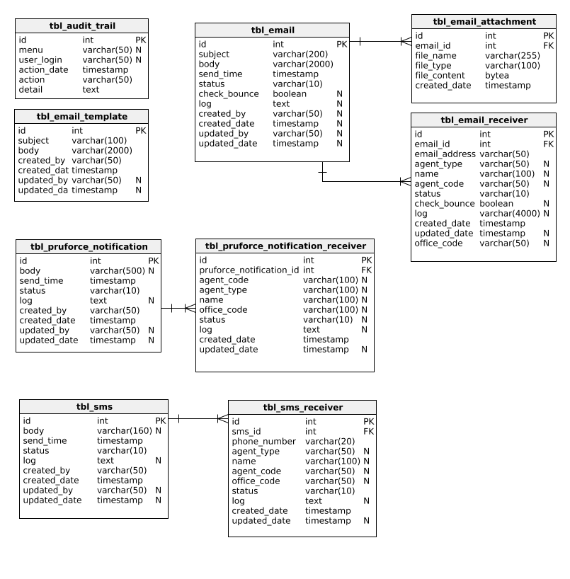

| **Requirement ID** | **Requirement Description** |
| --- | --- |
| 3.3.1.1 | Table name: tbl_email   |  |  |  |  |  |  | | --- | --- | --- | --- | --- | --- | | **Column Name** | **Type** | **Primary Key** | **Default Value** | **Nullable?** | **Foreign Key** | | id | Integer | Y |  | N |  | | subject | Character Varying (200) | N |  | N |  | | body | Character Varying (2000) | N |  | Y |  | | send_time | Timestamp with time zone | N |  | N |  | | status | Character Varying (10) | N |  | N |  | | check_bounce | Boolean | N |  | Y |  | | log | Text | N |  | Y |  | | created_by | Character Varying (50) | N |  | Y |  | | created_date | Timestamp with time zone | N |  | N |  | | updated_by | Character Varying (50) | N |  | Y |  | | updated_date | Timestamp with time zone | N |  | Y |  | |
| 3.3.1.2 | Table name: tbl_email_attachment   |  |  |  |  |  |  | | --- | --- | --- | --- | --- | --- | | **Column Name** | **Type** | **Primary Key** | **Default Value** | **Nullable?** | **Foreign Key** | | id | Integer | Y |  | N |  | | email_id | Integer | N |  | N | tbl_email.id | | file_name | Character Varying (255) | N |  | N |  | | file_type | Character Varying (100) | N |  | N |  | | file_content | Bytea | N |  | N |  | | created_date | Timestamp with time zone | N |  | N |  | |
| 3.3.1.3 | Table name: tbl_email_receiver  (Data in this table will be housekeeping for max 3 months)   |  |  |  |  |  |  | | --- | --- | --- | --- | --- | --- | | **Column Name** | **Type** | **Primary Key** | **Default Value** | **Nullable?** | **Foreign Key** | | id | Integer | Y |  | N |  | | email_id | Integer | N |  | N | tbl_email.id | | email_address | Character Varying (50) | N |  | N |  | | agent_type | Character Varying (50) | N |  | Y |  | | name | Character Varying (100) | N |  | Y |  | | agent_code | Character Varying (50) | N |  | Y |  | | status | Character Varying (10) | N |  | N |  | | check_bounce | Boolean | N |  | Y |  | | log | Character Varying (4000) | N |  | Y |  | | created_date | Timestamp with time zone | N |  | N |  | | updated_date | Timestamp with time zone | N |  | Y |  | | office_code | Character Varying (50) | N |  | Y |  | |
| 3.3.1.4 | Table name: tbl_email_template   |  |  |  |  |  |  | | --- | --- | --- | --- | --- | --- | | **Column Name** | **Type** | **Primary Key** | **Default Value** | **Nullable?** | **Foreign Key** | | Id | Integer | Y |  | N |  | | subject | Character Varying (100) | N |  | N |  | | body | Character Varying (2000) | N |  | N |  | | created_by | Character Varying (50) | N |  | N |  | | created_date | Timestamp with time zone | N |  | N |  | | updated_date | Timestamp with time zone | N |  | Y |  | | updated_by | Character Varying (50) | N |  | Y |  | |
| 3.3.1.5 | Table name: tbl_pruforce_notification   |  |  |  |  |  |  | | --- | --- | --- | --- | --- | --- | | **Column Name** | **Type** | **Primary Key** | **Default Value** | **Nullable?** | **Foreign Key** | | id | Integer | Y |  | N |  | | body | Character Varying (500) | N |  | Y |  | | send_time | Timestamp with time zone | N |  | N |  | | status | Character Varying (10) | N |  | N |  | | log | Text | N |  | Y |  | | created_date | Timestamp with time zone | N |  | N |  | | created_by | Character Varying (50) | N |  | N |  | | updated_by | Character Varying (50) | N |  | Y |  | | updated_date | Timestamp with time zone | N |  | Y |  | |
| 3.3.1.6 | Table name: tbl_sms   |  |  |  |  |  |  | | --- | --- | --- | --- | --- | --- | | **Column Name** | **Type** | **Primary Key** | **Default Value** | **Nullable?** | **Foreign Key** | | id | Integer | Y |  | N |  | | body | Character Varying (160) | N |  | Y |  | | send_time | Timestamp with time zone | N |  | N |  | | status | Character Varying (10) | N |  | N |  | | log | Text | N |  | Y |  | | created_date | Timestamp with time zone | N |  | N |  | | updated_date | Timestamp with time zone | N |  | N |  | | created_by | Character Varying (50) | N |  | Y |  | | updated_by | Character Varying (50) | N |  | Y |  | |
| 3.3.1.7 | Table name: tbl_sms_receiver  (Data in this table will be housekeeping for max 3 months   |  |  |  |  |  |  | | --- | --- | --- | --- | --- | --- | | **Column Name** | **Type** | **Primary Key** | **Default Value** | **Nullable?** | **Foreign Key** | | id | Integer | Y |  | N |  | | sms_id | Integer | N |  | N | tbl_sms.id | | phone_number | Character Varying (20) | N |  | N |  | | agent_type | Character Varying (50) | N |  | Y |  | | name | Character Varying (100) | N |  | Y |  | | agent_code | Character Varying (50) | N |  | Y |  | | office_code | Character Varying (50) | N |  | Y |  | | status | Character Varying (10) | N |  | N |  | | log | Text | N |  | Y |  | | created_date | Timestamp with time zone | N |  | N |  | | updated_date | Timestamp with time zone | N |  | Y |  | |
| 3.3.1.8 | Table name: tbl_pruforce_notification_receiver  (Data in this table will be housekeeping for max 3 months)   |  |  |  |  |  |  | | --- | --- | --- | --- | --- | --- | | **Column Name** | **Type** | **Primary Key** | **Default Value** | **Nullable?** | **Foreign Key** | | id | Integer | Y |  | N |  | | pruforce_notification_id | Integer | N |  | N | tbl_pruforce_notification.id | | agent_code | Character Varying (100) | N |  | Y |  | | agent_type | Character Varying (100) | N |  | Y |  | | name | Character Varying (100) | N |  | Y |  | | office_code | Character Varying (100) | N |  | Y |  | | status | Character Varying (10) | N |  | Y |  | | log | Text | N |  | Y |  | | created_date | Timestamp with time zone | N |  | N |  | | updated_date | Timestamp with time zone | N |  | Y |  | |
| 3.3.1.9 | Table name: tbl_audit_trail   |  |  |  |  |  |  | | --- | --- | --- | --- | --- | --- | | **Column Name** | **Type** | **Primary Key** | **Default Value** | **Nullable?** | **Foreign Key** | | id | Integer | Y |  | N |  | | menu | Character Varying (50) | N |  | Y |  | | user_login | Character Varying (50) | N |  | Y |  | | action_date | Timestamp with time zone | N |  | N |  | | action | Character Varying (50) | N |  | Y |  | | detail | Text | N |  | Y |  | |

### Data Access Requirements

| **Requirement ID** | **Requirement Description** |
| --- | --- |
| 3.3.2.1 | Agent profile is get from database Greenplum on isg.mv_agent_dcs   |  |  |  | | --- | --- | --- | |  | **Column Name** | **Type** | | Agent Type | agtype | character varying(2) | | Agent Number | agentnumber | character varying(8) | | Agent Name | surname | character varying(30) | | Agent Email Address | emailaddress | character varying(50) | | Agent Mobile Phone | mobilephone | character varying(16) | | Office Code | tsalesunt | character varying(5) | | GA Manager  (value : 1 or 0, If the agent is GAO then 1 otherwise 2) | isinsagof | text | |
| 3.3.2.2 | Office Code list got from:  *select distinct a.id.tsalesunt from isg.mv_agent_dcs a*  *where a.id.agType in ('AG', 'AA','AD', 'UM', 'SU', 'AM', 'MA')* |

### Data Import/Export Requirements

| **Requirement ID** | **Requirement Description** |
| --- | --- |
| <ID> | <Requirement Description> |
| <ID> | <Requirement Description> |

### Data Migration/Conversion Requirements

| **Requirement ID** | **Requirement Description** |
| --- | --- |
| <ID> | <Requirement Description> |
| <ID> | <Requirement Description> |

### Data Backup, Restore, and Archiving Requirements

| **Requirement ID** | **Requirement Description** |
| --- | --- |
| <ID> | <Requirement Description> |
| <ID> | <Requirement Description> |

## Batch Processes

### Batch Process

#### Send Email Scheduler

|  |  |
| --- | --- |
| Attribute ID | Batch Process Attribute |
| ID | 3.4.1.1 |
| Name | Send Email Scheduler |
| Status | New |
| Trigger | M-Control hit Rest API which provided by Distribution Communication System Application to send email |
| Post Condition | The scheduler will send the email to agent and update table tbl_email.status and tbl_email_receiver.status. |

#### Send SMS Scheduler

|  |  |
| --- | --- |
| Attribute ID | Batch Process Attribute |
| ID | 3.4.1.2 |
| Name | Send SMS Scheduler |
| Status | New |
| Trigger | M-Control hit Rest API which provided by Distribution Communication System Application to send SMS |
| Post Condition | The scheduler will send the SMS to agent and update table tbl_sms.status and tbl_sms_receiver.status. |

#### Send PRUforce Scheduler

|  |  |
| --- | --- |
| Attribute ID | Batch Process Attribute |
| ID | 3.4.1.3 |
| Name | Send Pruforce Scheduler |
| Status | New |
| Trigger | M-Control hit Rest API which provided by Distribution Communication System Application to send PRUforce push notification |
| Post Condition | The scheduler will send push notification pruforce to agent and update table tbl_pruforce_notification.status and tbl_ pruforce_notification _receiver.status. |

### Batch Description

### Batch Process Description - Main Flow

#### Send Email Scheduler

|  |  |
| --- | --- |
| **Step** | **Flow of Events** |
| **1** | M-Control hit Rest API which provided by Distribution Communication System Application to send email |
| **2** | Get a list of id from tbl_email where "send_time" less than current time and status "Pending". Based on the list of id, update tbl_email status to "Sending". |
| **3** | Get a list of Email Receiver where emailId in a list of email id. |
| **4** | Make an object that contains transactionId, transactionTime, signatureString, processCode, channelId, tos, subject, message, and listAttachment. |
| **5** | Send via Web Service |
| **6** | Get response, if httpStatus is 200, update status in tbl_email_receiver become Success otherwise Error |
| **7** | After the message sends to all receiver and all receiver status in tbl_email_receiver is a success, update status in table_email become Success otherwise Error. |

#### Send SMS Scheduler

|  |  |
| --- | --- |
| **Step** | **Flow of Events** |
| **1** | M-Control hit Rest API which provided by Distribution Communication System Application to send SMS |
| **2** | Get a list of id from tbl_sms where "send_time" less than current time and status "Pending". Based on the list of id, update tbl_email status to "Sending". |
| **3** | Get a list of Email Receiver where smsId in a list of sms id. |
| **4** | Make object that contain Body, Status, Created Date, Send Time. |
| **5** | Send via Web Service |
| **6** | Get response, if httpStatus is 200, update status in tbl_sms_receiver become Success otherwise Error |
| **7** | After the message send to all receiver and all receiver status in tbl_sms_receiver is success, update status in table_sms become Success otherwise Error. |

#### Send PRUforce Scheduler

|  |  |
| --- | --- |
| **Step** | **Flow of Events** |
| **1** | M-Control hit Rest API which provided by Distribution Communication System Application to send PRUforce |
| **2** | Get data from tbl_pruforce_notification where send_time less than current time and status Pending |
| **3** | Get a list of Email Receiver where pruforceId in a list of pruforce notification id. |
| **4** | Make object that contain Subject, Body, Status, Attachment, Created Date, Send Time. |
| **5** | Send via Web Service |
| **6** | Get response, if httpStatus is 200, update status in tbl_pruforce_notification_receiver become Success otherwise Error |
| **7** | After the message send to all receiver and all receiver status in tbl_ pruforce_notification _receiver is success, update status in table_ pruforce_notification become Success otherwise Error. |

### Batch Process Description - Alternate Flow

|  |  |
| --- | --- |
| **Step** | **Flow of Events** |
| **< Step ID>** | <Describe step, what tasks will be performed> |
| **< Step ID>** | <Describe step, what tasks will be performed> |

### Batch Process Dependencies

<Identify the dependencies for this batch process. Which data sources must be available for the batch to complete? Which system messages must have been received from external systems? Ensure that the main flow and alternative flows address what the system should do when these dependencies are not available.>

|  |
| --- |
| **Dependencies** |
| **<Insert Dependency>** |
| **<Insert Dependency>** |

### Batch Process Data Reference

<Identify the source(s) of the data used by the batch process and the locations used to store data when the batch process is complete. Indicate the volume of data which is expected to be processed by the batch process.>

|  |  |  |  |
| --- | --- | --- | --- |
| **Source Name** | **Source Location** | **Data Volume** | **Source Description** |
| **<Name>** | <Location> | <Volume> | <Describe source data> |
| **<Name>** | <Location> | <Volume> | <Describe source data> |

### Security

<List the users which have access to the batch process. >

|  |  |
| --- | --- |
| **User ID** | **Access Rights** |
| **<User ID>** | <Insert Access Rights> |
| **<User ID>** | <Insert Access Rights > |

## Non-Functional Requirements

| **Requirement ID** | **Requirement Description** |
| --- | --- |
| 3.5.1 | Performance Requirements to send information on the same time for 250,000 – 280,000 agents/info:  Response times (the amount of time it takes for the application to be loaded, a page to be loaded on the browser, refresh time etc)    Processing times (the amount of time required to perform certain functions, calculations etc.) |
| 3.5.2 | Volume Requirements: Total outbound information will be 250,000 – 280,000 agents / info or average 265,000 agents / info.   |  |  |  |  |  |  | | --- | --- | --- | --- | --- | --- | |  | **Numbers of Info (Annually)** | | | | | |  | **2015** | **2016 (Pred.)** | **2017**  **(Pred.)** | **2018**  **(Pred.)** | **2019**  **(Pred.)** | | Agency Update, Memo Update, Flyer | 336 | 336 | 336 | 336 | 336 | | Press Release | 6 | 6 | 6 | 6 | 6 | | PRUgalaxy | - | - | 300 | 1200 | 1200 | | Contest | 15 | 18 | 18 | 18 | 18 | | **Total Info** | **357** | **360** | **660** | **1560** | **1560** |   No. of user (who can access the application simultaneously) = 3 user |
| 3.5.3 | Availability Requirements:  Hours of operation – It will depend on Activities request / Adhoc  Locations of operation – The information will be sent centrally from Jakarta to all around Indonesia. |
| 3.5.4 | Reliability Requirements:  Acceptable threshold for application or system down-time  Mean time to Recovery – It will depend on Activities request / Adhoc event. If the system down when the activity is running, then the system has to back online not more than 30 minutes. |
| 3.5.5 | Usability Requirements:  Look and feel standards – simple better (female user)  Internationalization/Localization requirements – languages English (U.S) (for editor and content) and Bahasa Indonesia (for Content) |

## Security Requirements

### User Role/Authorization Control Requirements

| **Requirement ID** | **Requirement Description** |
| --- | --- |
| <ID> | <The system must enable the <User Role> user to perform the following system functions :>  <System Function>  <System Function> |

### User Administration Requirements

| **Requirement ID** | **Requirement Description** |
| --- | --- |
| <ID> | <Requirement Description> |
| <ID> | <Requirement Description> |

### System Administration Requirements

| **Requirement ID** | **Requirement Description** |
| --- | --- |
| <ID> | <Requirement Description> |
| <ID> | <Requirement Description> |

### Network Security Requirements

| **Requirement ID** | **Requirement Description** |
| --- | --- |
| <ID> | <Requirement Description> |
| <ID> | <Requirement Description> |

### Physical Security Requirements

| **Requirement ID** | **Requirement Description** |
| --- | --- |
| <ID> | <Requirement Description> |
| <ID> | <Requirement Description> |

### User ID Requirements

| Requirement ID | Requirement Description |
| --- | --- |
| <ID> | <There must be a procedure in place that requires written authorization prior to the creation of a User ID.> |
| <ID> | <There must be a procedure in place to notify the System Administrator of terminations of employment and/or changes in system access.> |
| <ID> | <There must be a mechanism and/or procedure in place for the deactivation of User IDs upon change in status, such as termination of employment.> |
| <ID> | <The system must require User IDs to be unique.> |
| <ID> | <The system must provide the ability to create a new user.> |
| <ID> | <The system must provide the ability to suspend and/or deactivate (lock out) a user.> |
| <ID> | <The system must provide the ability to reactivate a user.> |

# Glossary

These are the abbreviations, acronyms, and terms that are specific to this FSD:

| **Abbreviation, Acronym, and Term** | **Definition** |
| --- | --- |
| <Abbreviation, Acronym, or Term> | <Definition> |
| <Abbreviation, Acronym, or Term> | <Definition> |
| <Abbreviation, Acronym, or Term> | <Definition> |
| <Abbreviation, Acronym, or Term> | <Definition> |

# Reference Documents

The following reference documents were used during the development of this FSD:

| Document Number | Document Title | Document Type |
| --- | --- | --- |
| <Document Number> | <Document Title> | <Document Type> |
| <Document Number> | <Document Title> | <Document Type> |

# Attachments/Appendix

There are no attachments in this FSD

<OR>

## Site Map

<Attachment>

## Use Case Diagram

<Attachment>

## Page Specification

<Attachment>

## Report Design

<Attachment>

## User Interface and User Experience Design

<Attachment>